Week-04-Decision Making and Looping -While, do…While and for

Week -04-01-practice Session-coding

Reg no:241801289

Name: Tamilselvan .k

Q1)

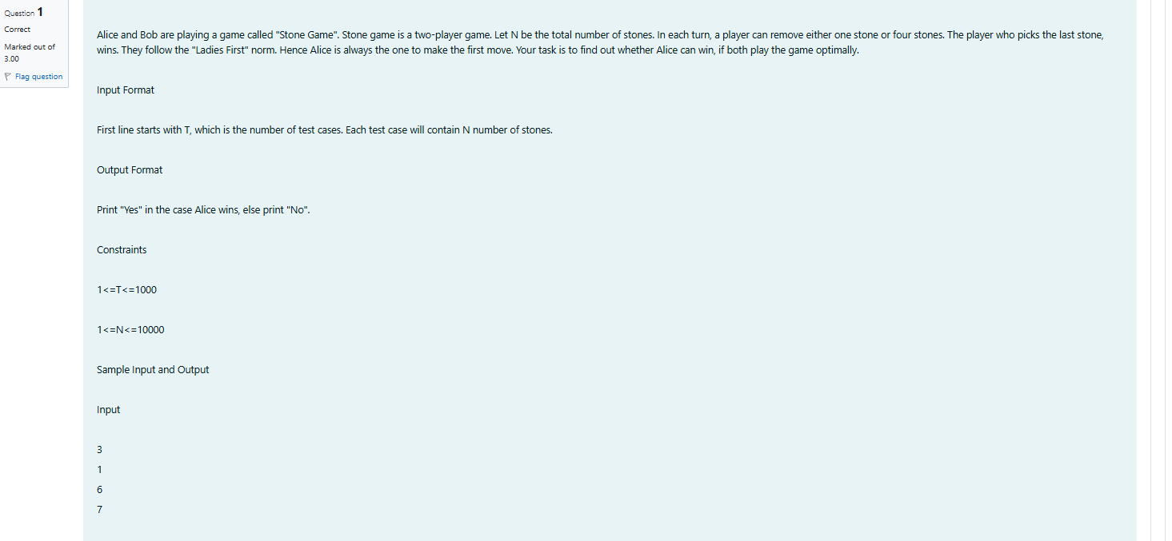

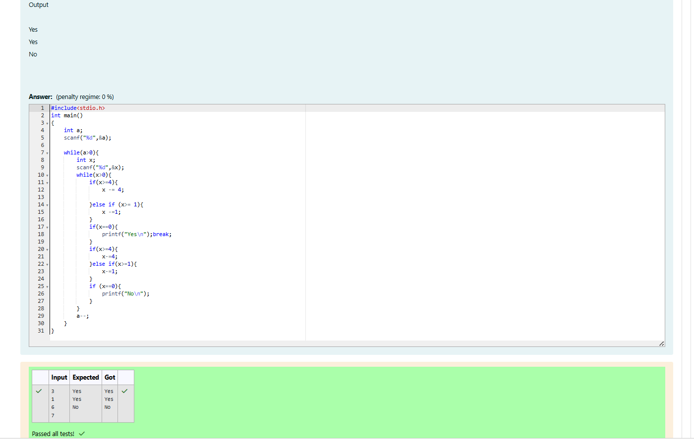

Week -04-01-practice Session-coding

Reg no:241801289

Name: Tamilselvan .k

Q2)

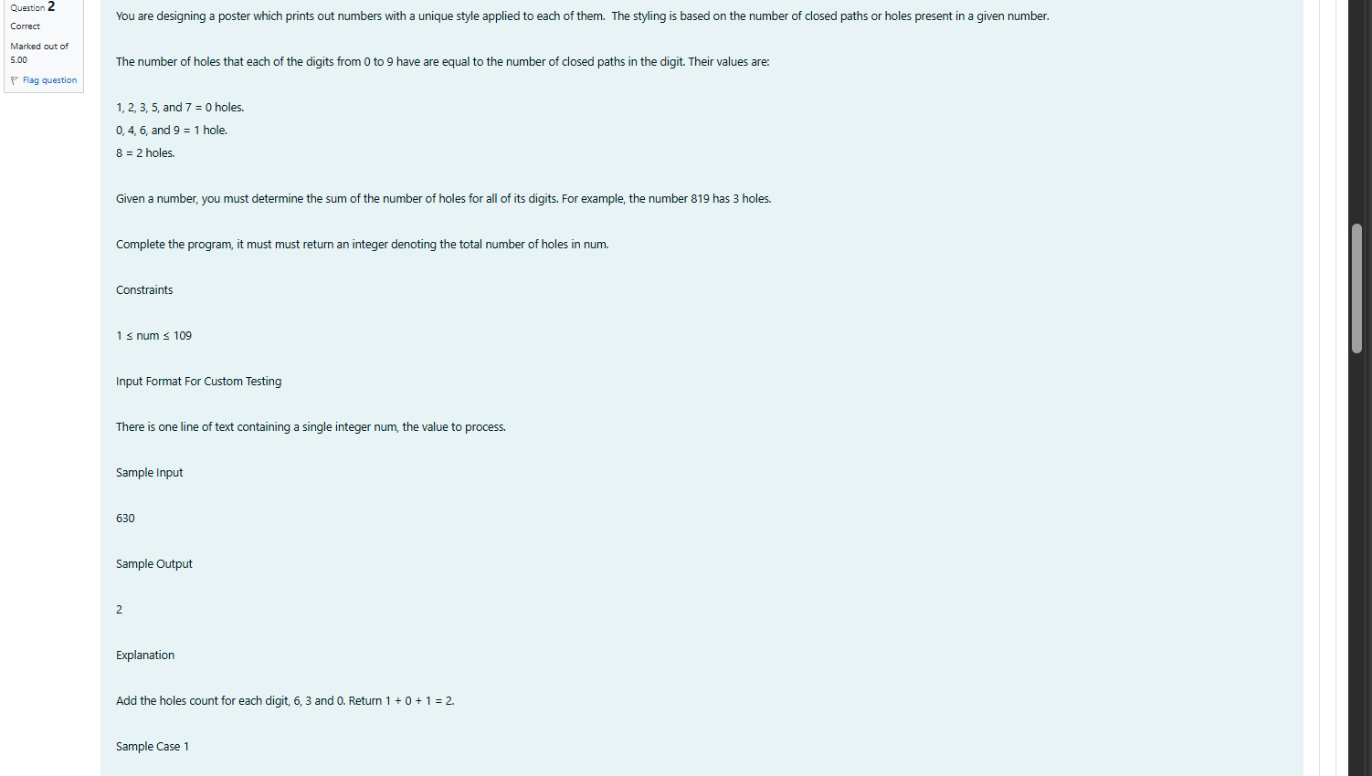

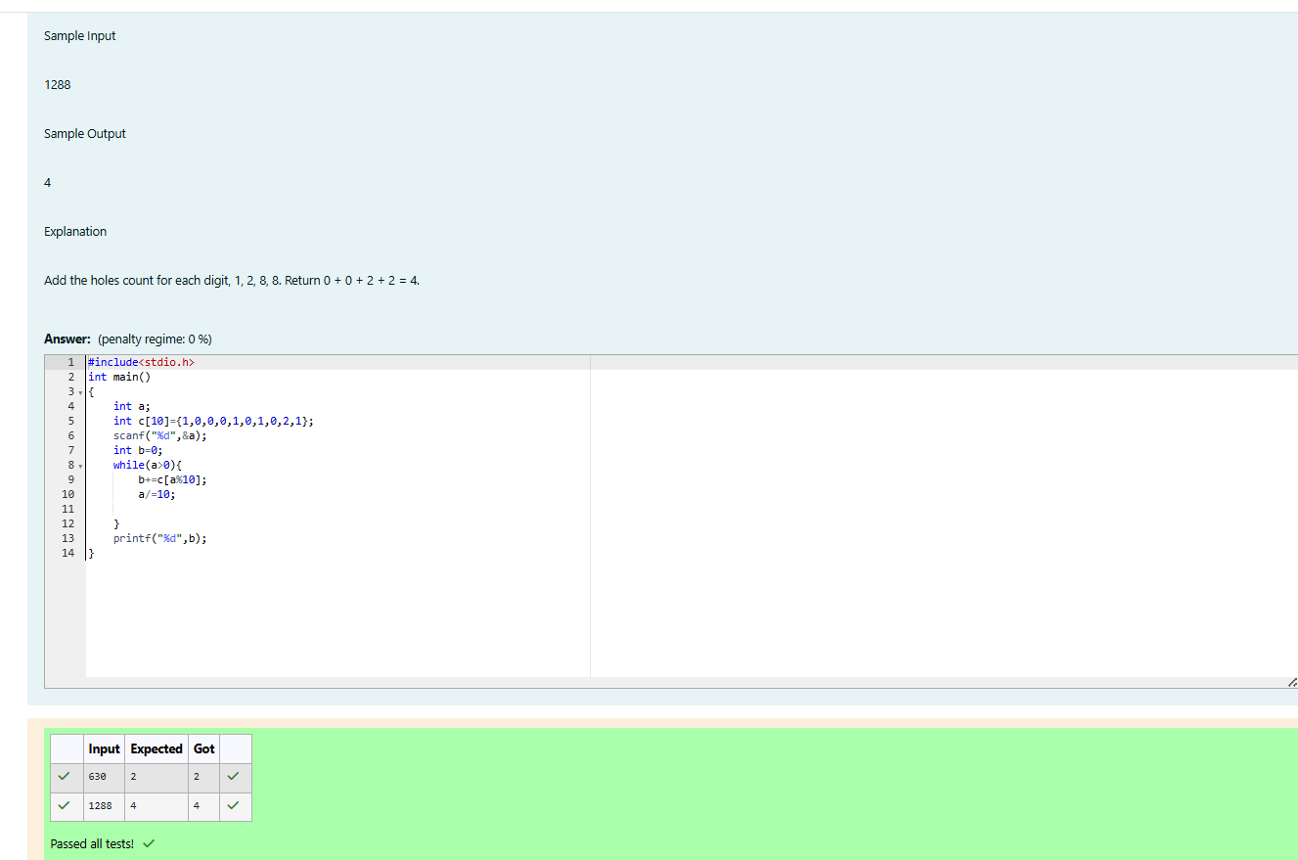

Week -04-01-practice Session-coding

Reg no:241801289

Name: Tamilselvan .k

Q3)

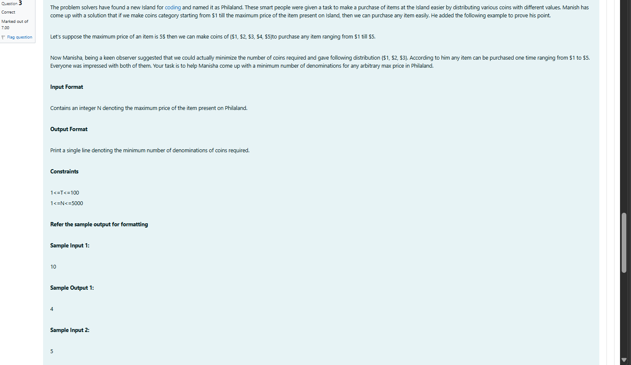

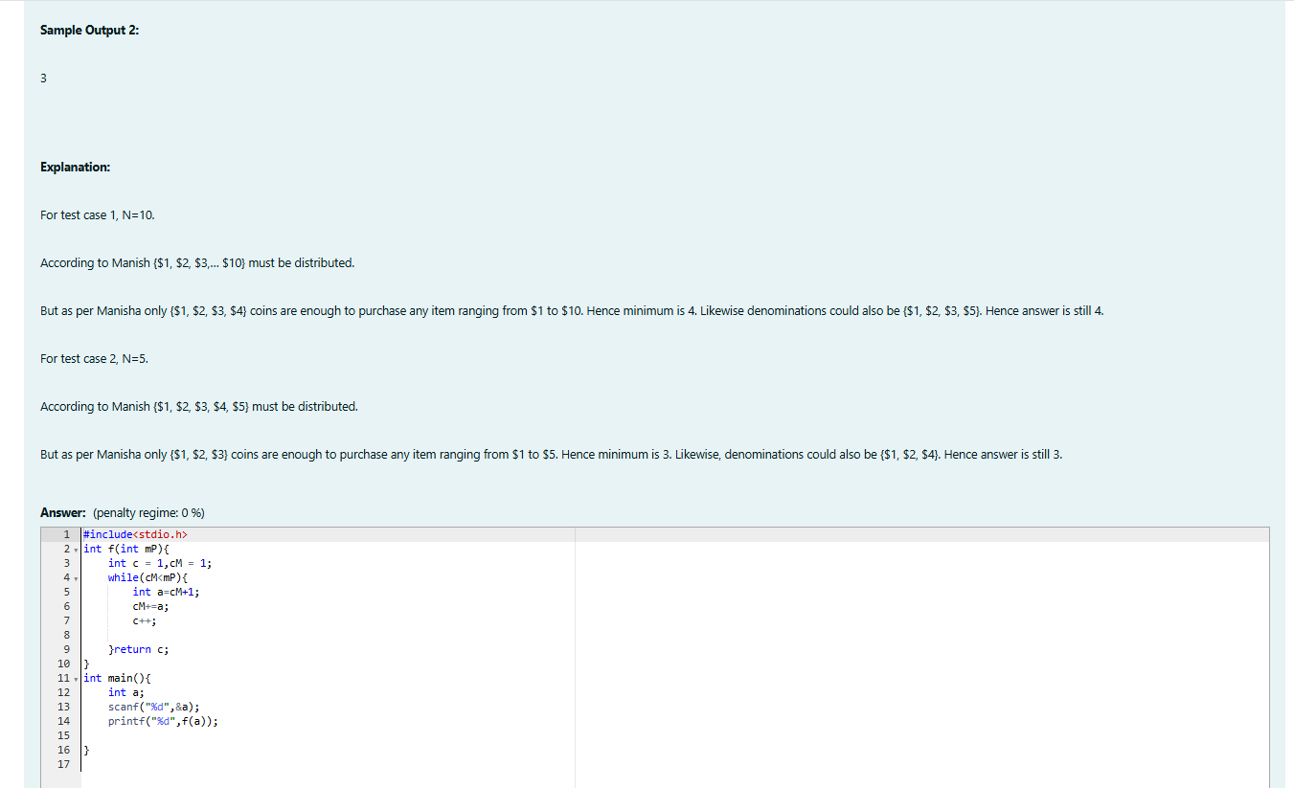

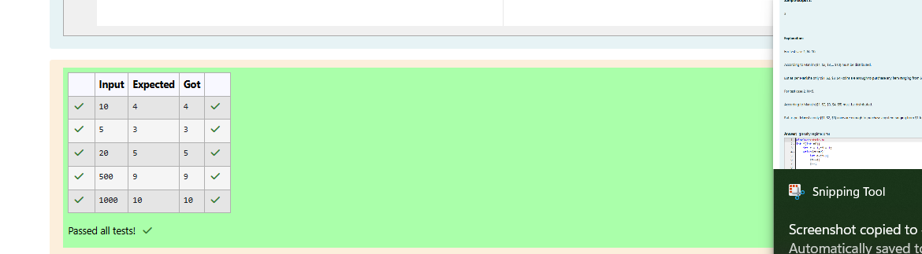

Week -04-02-practice Session-coding

Reg no:241801289

Name: Tamilselvan .k

Q1

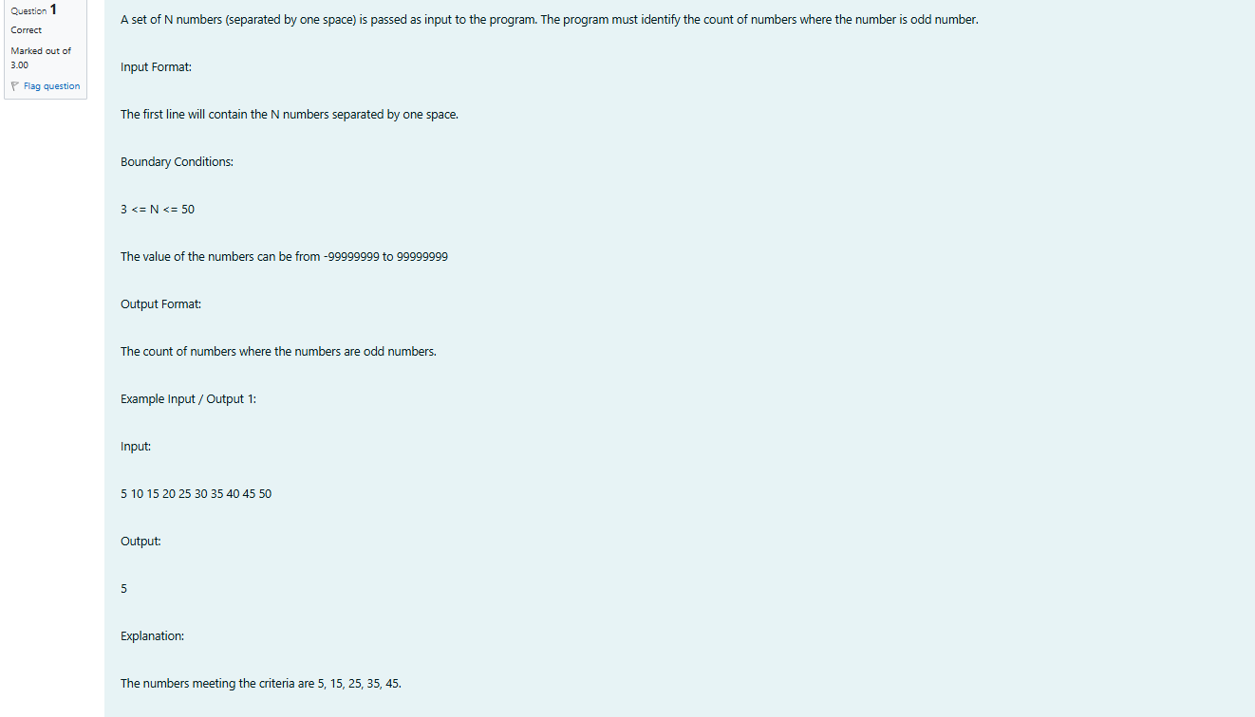

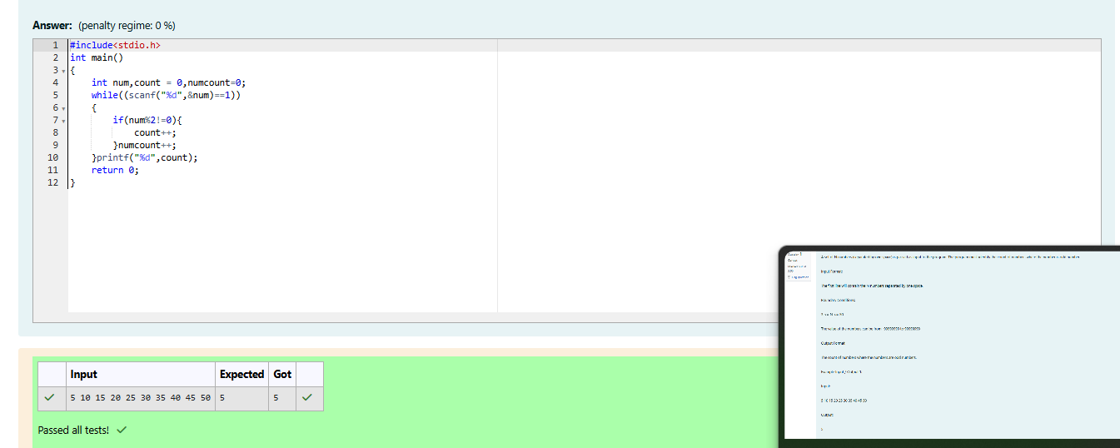

Week -04-02-practice Session-coding

Reg no:241801289

Name: Tamilselvan .k

Q2

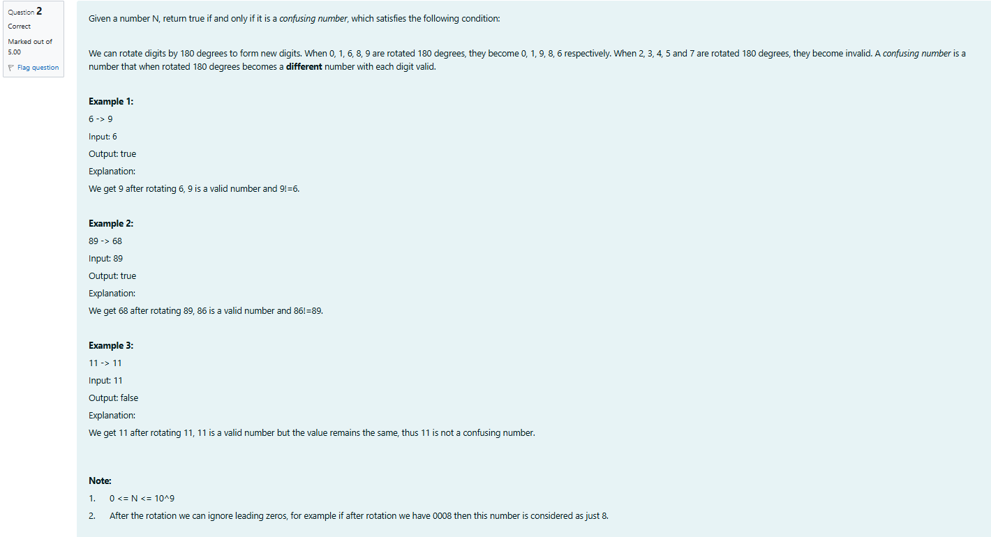

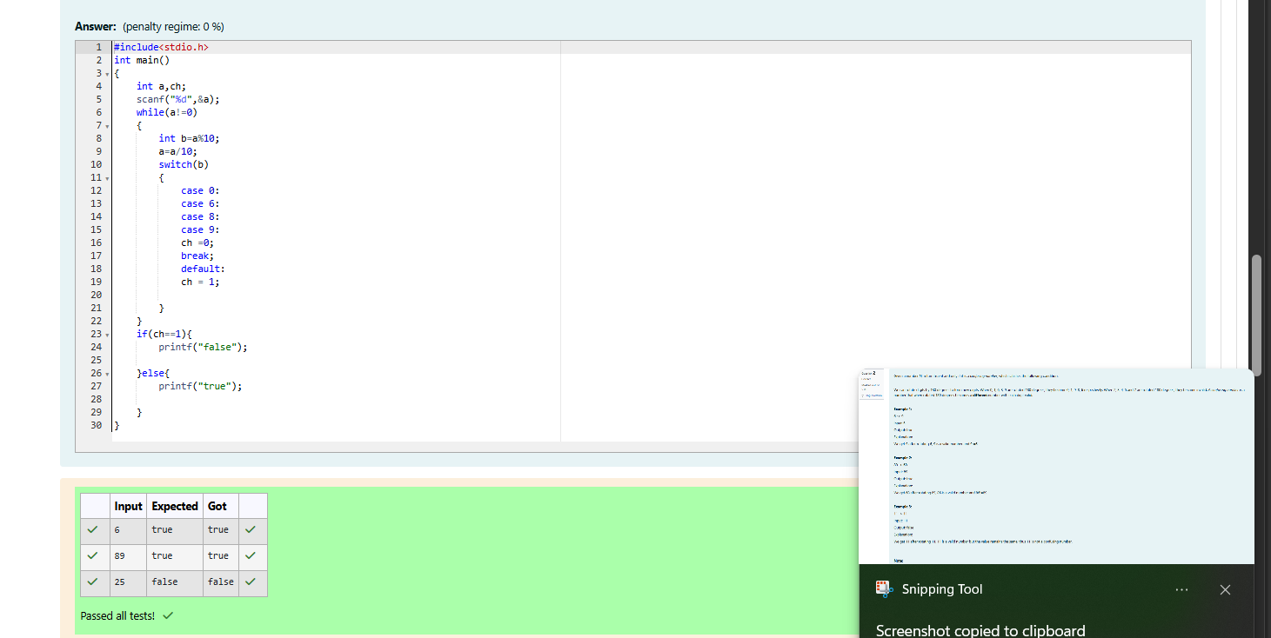

Week -04-02-practice Session-coding

Reg no:241801289

Name: Tamilselvan .k

Q3

